No:20140723-A

APPROVAL SHEET
Customer:

ROHS COMPLIANT
Part Number:
Part No.: -20-24.000

Holder: SMD3225

Frequency: 24.000MHz
Manufacturer: Electronics
Date: 2014/07/23

Drawn | Checked | Approved

(For Customer Use)

Acceptable | Non-Acceptable

1.This specification applies to quartz crystal unit with a frequency of 24.000MHz.
2.Electrical characteristics:
 | Item | Conditions | Specifications
2.1 | Holder type |  | SMD3225
2.2 | Norminal frequency |  | 24.000MHz
2.3 | Adjustment tolerance | Reference temperature shall be 25+/-2℃ | +/-20ppm
2.4 | Frequency tolerance over temperature Range | Reference temperature shall be 25+/-2℃ | +/-20ppm
2.5 | Operating temperature range |  | -20℃--+75℃
2.6 | Storage temperature range |  | -40℃--+85℃
2.7 | Resonance resistance |  | <30 ohm
2.8 | Load capacitance |  | 20PF
2.9 | DLD | 0.01-100uW/20 steps | NA
2.10 | RLD | 0.01-100uW/20 steps | NA
2.11 | Shunt capacitance | C0 | 7.0PF max
2.12 | Motional capacitance | C1 | NA
2.13 | Pulling Sensitivity | S | NA
2.14 | Drive level |  | 100Uw typ
2.15 | Insulation resistance | DC/100V shall be applied for 1min ,then measurement  shall be made between terminal and case. | >500M ohm
2.16 | Aging/year |  | <+/-2ppm
3.Measurement Circuit:
3.1 Frequency measurement:
Measurement circuit: 250B( Saunders)
Load capacitance:20PF Drive level : 100uW
  - Resistance measurement
Measurement circuit:250B(Saunders)
Load capacitance :Series Drive level : 100uW
4. Construction
4.1 Crystal enclosure seal:
Seam seal resistance weld cold weld
  - crystal enclosure medium
nitrogen vacuum dry air

5.Dimension:
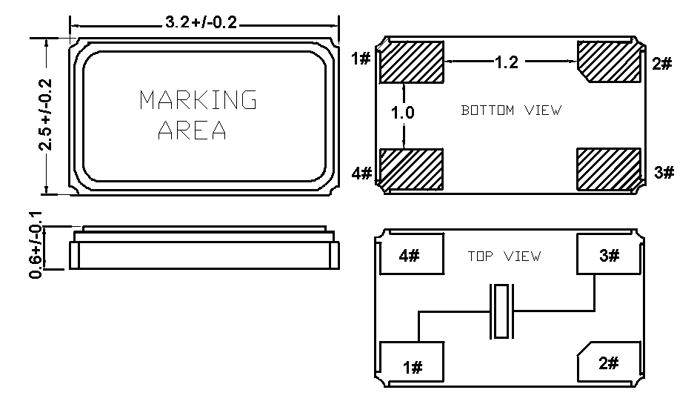

6. Marking
Laser Marking Ink Marking

24.000
MHz

